TYPING SPEED INCREASER

A PROJECT REPORT

*In partial fulfilment for the award of the degree*

*Of*

**BACHELOR OF ENGINEERING**

IN

# COMPUTER SCIENCE AND ENGINEERING



Under the guidance of Submitted by

Ravinder kaur Smriti Rani (1830033)

Associate /Assistant Professor Aakriti raj (1830040)

CSE Department Dikshita Garg (1830041)

SANT LONGOWAL INSTITUTE OF ENGINEERING AND TECHNOLOGY,

LONGOWAL – 148106, DISTRICT- SANGRUR, PUNJAB, INDIA

January, 2021

**TABLE OF CONTENTS**

1. Certificate
2. Acknowledgement
3. Abstract
4. List of Tables
5. List of Figures
6. Chapter 1. Introduction
7. Chapter 2. Literature Review
8. Chapter 3. Problem Definition
9. Chapter 4. Objectives
10. Chapter 5. Methodology Used
11. Chapter 6. Results and Screenshots
12. Chapter 7. Conclusion and Future Scope References

**ACKNOWLEDGEMENT**

It is my proud privilege and duty to acknowledge the kind of help and guidance received from several people in preparation of this report. It would not have been possible to prepare this report in this form without their valuable help, cooperation and guidance. I take this opportunity to express a deep sense of gratitude towards my guide MRs. RAVINDER KAUR, for providing excellent guidance, encouragement and inspiration throughout the project making. Over and above this, small queries on my part were constantly addressed and taken up by her with on a regular basis which helped all the members to see the project come through. I would also like to thank MRS. MONIKA SHARMA for her valuable suggestions and helpful discussions.I am also grateful to the friends that provided a completely stress- free working environment throughout the tenure of the project. Last but not the least, we wish to thank our parents for financing our studies in this

college as well as for constantly encouraging us to learn engineering. Their personal sacrifice in providing this opportunity to learn engineering is gratefully acknowledged.

**ABSTRACT**

Using Python programming language , we built an exciting project through which we can check

and even improve our typing speed. It’s a very useful game to track our typing speed

and to improve it with regular practice.

Since python has clean object-oriented design, provides enhanced process control capabilities , and possesses strong integration and text processing capabilities and its own unit testing framework, all of which contribute to the increase in its speed and productivity we made our project in this programming language. Python offers excellent readability and uncluttered simple to learn syntax which helps beginners to utilize this programming language.

The codestyle guidelines ,PEP8, provides a set of rules to facilitate the formatting of code. Additionally, the wide base of users and active developers has resulted in a rich internet resource bank to encourage development and the continued adoption of the language. The Typing Speed in Python is a simple project for improving your Typing speed. It is a simple typing challenge game mini-project. This is like a game, one-by-one random word will pop up on your screen. It has the feature where it has the displayed options like your score, time left and a new word comes after we write the displayed word.

**LIST OF TABLES**

|  |  |
| --- | --- |
| Chapter-1 | Introduction |
| Chapter-2 | Literature Review |
| Chapter-3 | Problem Definition |
| Chapter-4 | Objectives |
| Chapter-5 | Methodology used |
| Chapter-6 | Results and screenshots |
| Chapter-7 | Conclusion and future scope references |

**LIST OF FIGURES**

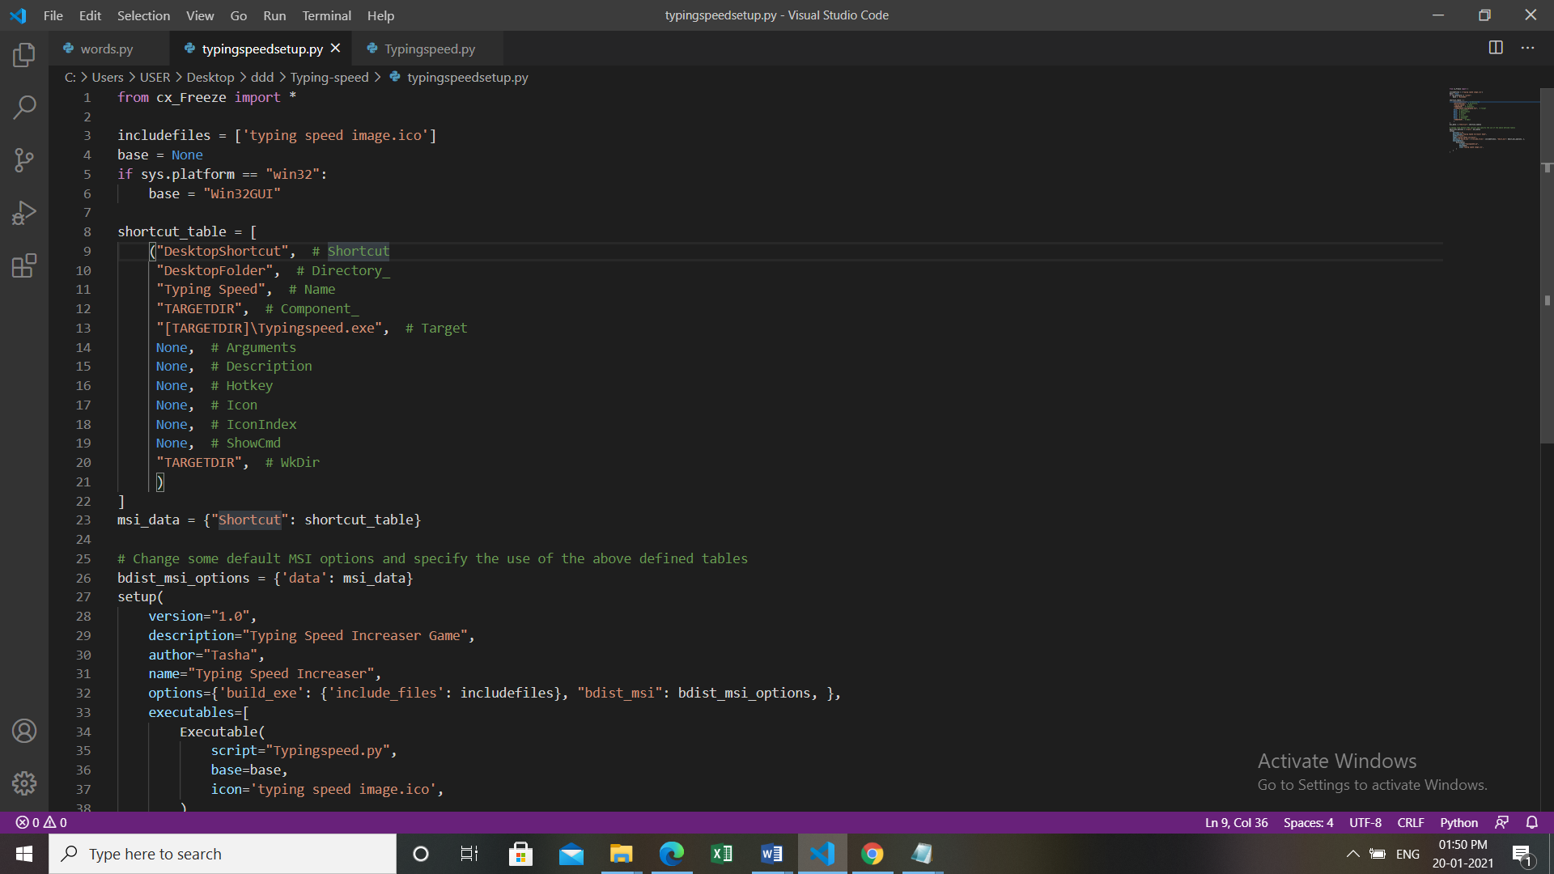

FIG 1: Typing Speed Increaser

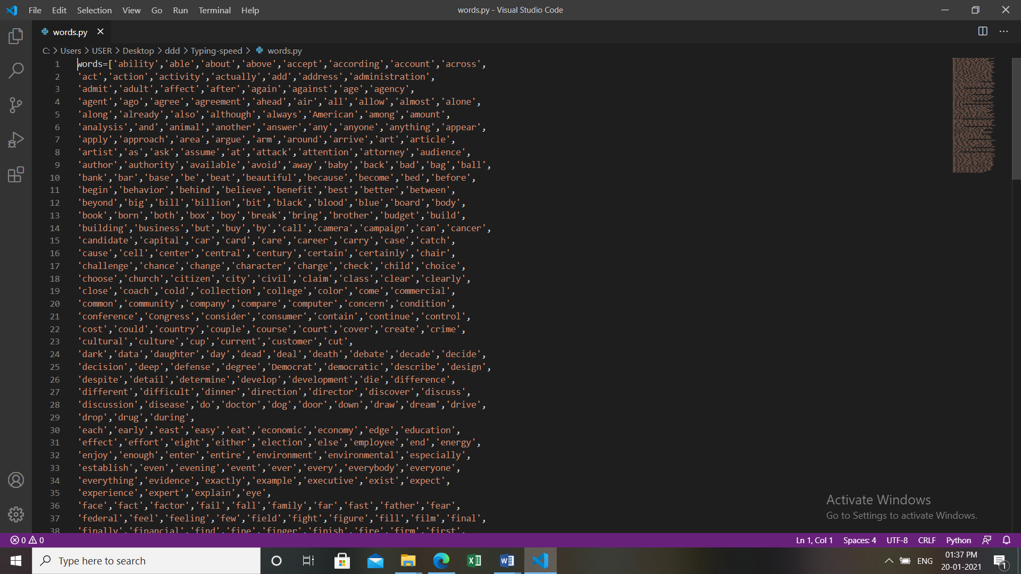

FIG 2: Typing Speed Increaser

**CHAPTER-1**

**INTRODUCTION**

We all have played typing speed game which is a very useful game to track the typing speed and to improve it with regular practice.

So in this project we built our own typing speed game in python using various inbuilt python libraries.

The speed typing test python project is written in python programming language,This speed typing test python project idea, we have built an exciting project through which we can check and even improve our typing speed. A Python typing speed test is good for the students or beginners to improve their typing speed skills, and also in this python typing game is good for the beginners in python programming world, because the syntax is easy to learn and understand for everyone. This project contains only the user side. It is a simple typing challenge game mini-project. This is like a game, one-by-one random word will pop up on your screen. It has the feature where it has the displayed options like your score, time limit, and a new word comes after we write the displayed word and press enter.

**CHAPTER-2**

**LITERATURE REVIEW**

**A good typing method not only enables faster writing, it also frees up the brain’s resources for the complex mental processes that writing requires (Johansson et al., 2009). Regular practice and good typing skills therefore allow students to write better (Wideman and Owston, 2000). Furthermore, their typed texts are of a higher quality than those written by hand (Crook, 2007). Researchers recommend that students learn the correct technique as early as possible (Wichter et al., 1997), preferably through frequent 15-minute sessions over the course of more than one school year (Losier, 2002).**

**The world’s first typist was Lillian sholes from Wisconin,the daughter of Christopher sholes,who invented the first practical typewriter.User interface features such as spell checker and autocomplete serve to facilitate the speed up typing and to prevent or correct errors the typist make make.**

**Keeping in mind the varous benefits of typing,wo got the idea of developing a speed typing test program in the very much popular and portable programming language which is python.we tried using the various python libraries to make our typing project more and more interesting and efficient.**

**CHAPTER-3**

**PROBLEM DEFINITION**

**These days typing can seem like it is not such an important skillas it once was.example-we are becoming increasingly used to talking to our machines with the advances being made by google home,alexa,cortana and Siri.** But typing remains a fundamental skill ,and it is still one of the most important computer skills you can learn. Learning to type fast and accurately will help us in many ways in life, and it should be considered an essential skill for anyone who sees themselves working with a computer in some capacity.

Typing is something most of us will have to do in our jobs .whether you work in an office or not,you will probably end up having to type on a computer keyboard on a weekly or even on daily basis.

Everyone is looking for ways to be more productive both in the workplace and at home, and typing faster is a simple way to get more done.

Posture may not be the first thing you think about when you decide to increase your typing speed, but it can certainly benefit. Another benefit of learning to type faster is that you will not have to look at the keyboard and think about where your fingers are going. Once you are typing fast, you will be able to look directly at the screen, and your fingers will type without you even thinking about the movements.

**CHAPTER-4**

**OBJECTIVES**

There are few reasons why learning how to type fast is so beneficial in general life and in work.

**Save Time**

Typing is something most of us will have to do a lot in our jobs. Whether you work in an office or not ,you will probably end up having to type on a computer keyboard on a weekly or even on a daily basis.

It stands to reason that the faster you can type,the more time you will save. When you are tasked with typing up a report, or even when you have to send an email, if you can do so quickly while remaining accurate, you could end up saving a lot of time.

**Be More Productive**

Everyone is looking for ways to be more productive both in the workplace and at home, and typing faster is a simple way to get more done.

If you learn to double the speed you type, you can essentially get twice as much done in the same space of time. Employers might even want to ensure their employees are trained up in touch-typing due to the productivity boost it could lead to.

And if you are an employee, you could learn how to increase your typing speed to impress your boss, or you can simply give yourself more time to spend on other things.

**Improve Your Posture**

Posture may not be the first thing you think about when you decide to increase your typing speed, but it can certainly benefit.

No matter whether you can touch type or not, you will still spend a lot of your time typing in almost any office-based role. Everyone knows that sitting down at your desk for long periods of time without a break is bad for your posture, so it makes sense to reduce the amount of time you sit down.

When you learn to touch type, you will also learn about correct typing posture. It's very important to sit up properly in order to stop your neck from becoming stiff and prevent your wrists from causing you pain. You will become more aware of correct posture when you learn to type properly, and you also won't have to keep looking down at your keyboard, which gives your neck a break and reduces aching.

**Improve Your Focus**

Another benefit of learning to type faster is that you will not have to look at the keyboard and think about where your fingers are going. Once you are typing fast, you will be able to look directly at the screen, and your fingers will type without you even thinking about the movements.

This means that you will be able to improve your focus. Every time you look down and try to find a key, you are losing concentration, so you will be able to focus more on what you are trying to say than the actual letters that you are typing.

**Better Accuracy**

Learning to touch type is not just about learning how to type faster: It's also about learning how to type with greater accuracy.

**Find More Opportunities**

Finally, because touch-typing is such a useful skill that boosts productivity in the workplace, it can help you to find more and better opportunities when it comes to getting a job.

When applying for a job, being able to type fast and accurately is going to put you at a big advantage. Employers like to know that their employees can type properly because it will make them more productive and improve the accuracy of their work.

**CHAPTER-5**

**Methodology/Technology or any specific tool to be used**

**PYTHON**

Python is an interpreted, high-level and general-purpose programming language. Python's design philosophy emphasizes code readability with its notable use of significant whitespace. Its language constructs and object-oriented approach aim to help programmers write clear, logical code for small and large-scale projects.

Python is dynamically typed and garbage-collected. It supports multiple programming paradigms, including structured (particularly, procedural), object-oriented, and functional programming. Python is often described as a "batteries included" language due to its comprehensive standard library.

**IMPORT**

The import keyword is used to import other modules into a Python script. We use the import keyword to import the math module into the namespace of our script. We print the PI value. We use the as keyword if we want to give a module a different alias. The import keyword finds and loads a package, a sub-package or a module if they are found in the system using the import mechanism. Once a module is loaded, the name of the imported module is introduced in the current scope where the import statement is executed.

**SLIDER**

A slider is a Tkinter object with which a user can set a value by moving an indicator. ... A slider is created with the Scale method(). Using the Scale widget creates a graphical object, which allows the user to select a numerical value by moving a knob along a scale of a range of values.

**TKINTER**

Tkinter is Python's de-facto standard GUI (Graphical User Interface) package. It is a thin object-oriented layer on top of Tcl/Tk.

Tkinter is not the only Gui Programming toolkit for Python. It is however the most commonly used one. CameronLaird calls the yearly decision to keep TkInter "one of the minor traditions of the Python world."

**RANDOM**

To get access to the random module, we add from random import * to the top of our program (or type it into the python shell). ... Note if you run the program again, you get different (random) results. This program illustrates the functions randrange and random. We will most often be using randrange.

**IMPORT THREADING**

Threading in python is used to run multiple threads (tasks, function calls) at the same time. ... Python threads are used in cases where the execution of a task involves some waiting. One example would be interaction with a service hosted on another computer, such as a webserver. If a class or a program has immutable state then the class is necessarily thread-safe. ... Similarly, the shared state in an application where the same thread mutates the state using an operation that translates into an atomic bytecode instruction can be safely read by multiple reader threads.

**IMPORT TIME**

The time() function returns the number of seconds passed since epoch. For Unix system, January 1, 1970, 00:00:00 at UTC is epoch (the point where time begins).

**MESSAGEBOX**

The messagebox module is used to display the message boxes in the python applications.  
The tkMessageBox module is used to display message boxes in your applications. This module provides a number of functions that you can use to display an appropriate message .

**CX_Freeze**

[cx_Freeze](https://pypi.python.org/pypi/cx_Freeze) is a set of scripts and modules for freezing Python scripts into executables, in much the same way that [py2exe](http://www.py2exe.org/) and [py2app](https://py2app.readthedocs.io/en/latest/) do. Unlike these two tools, cx_Freeze is cross-platform and should work on any platform that Python itself works on. It supports Python 2.7 or higher (including Python 3).

**CHAPTER-6**

**RESULTS AND SCREENSHOTS**

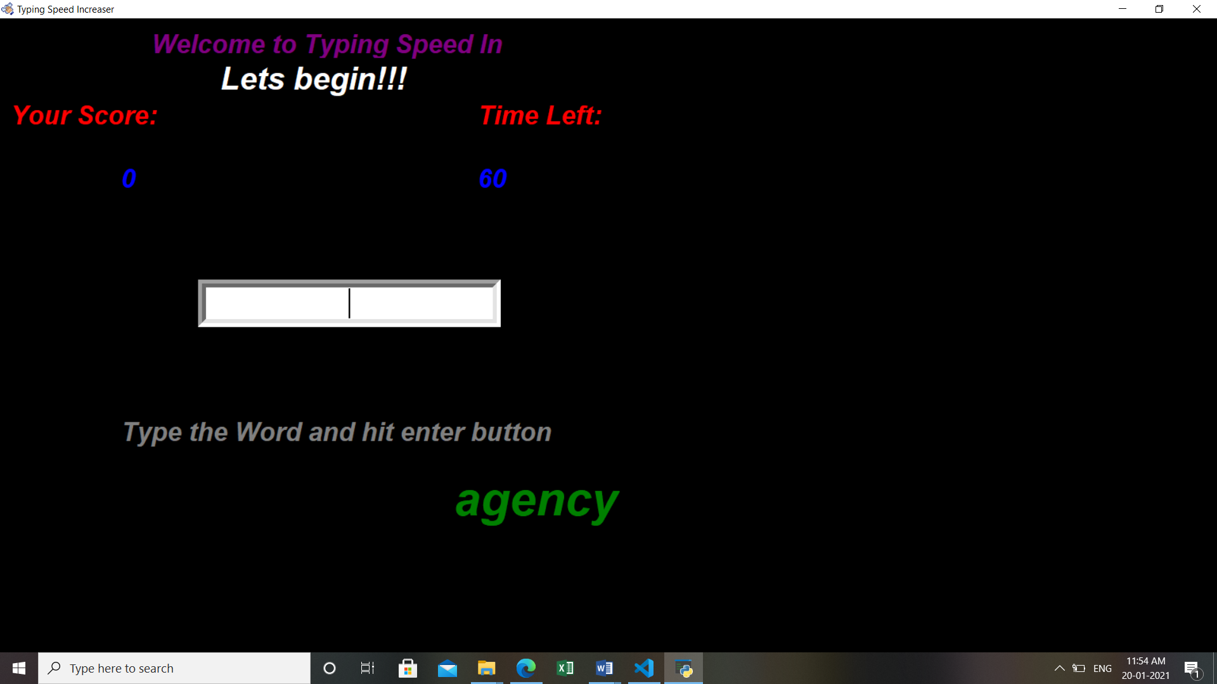

FIG 1: Typing Speed Increaser

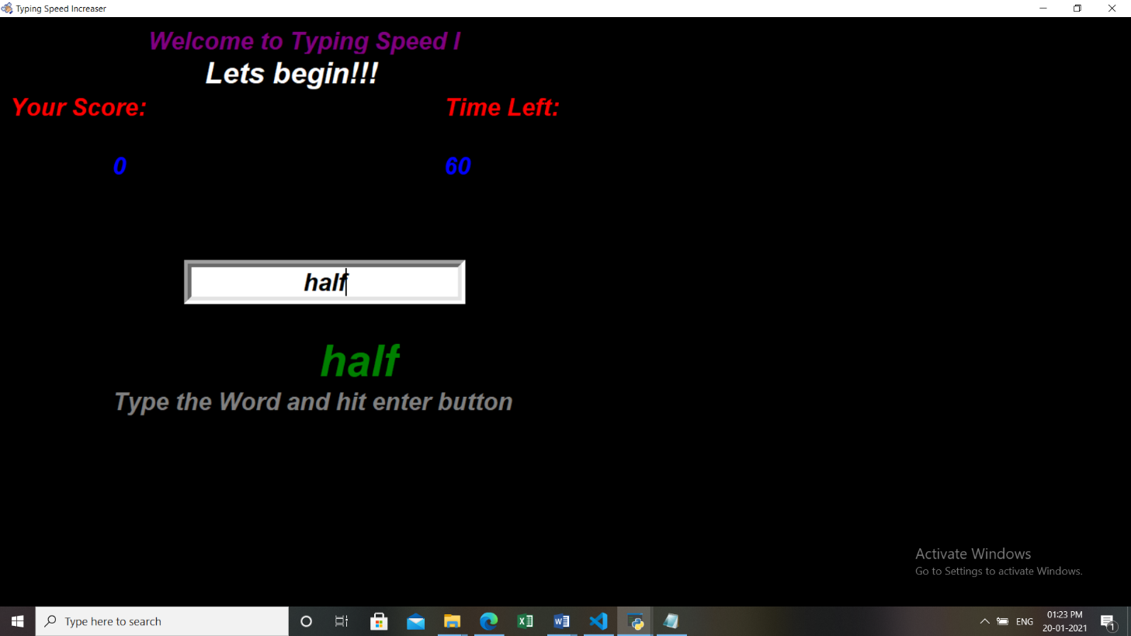

FIG 2: Typing speed Increaser

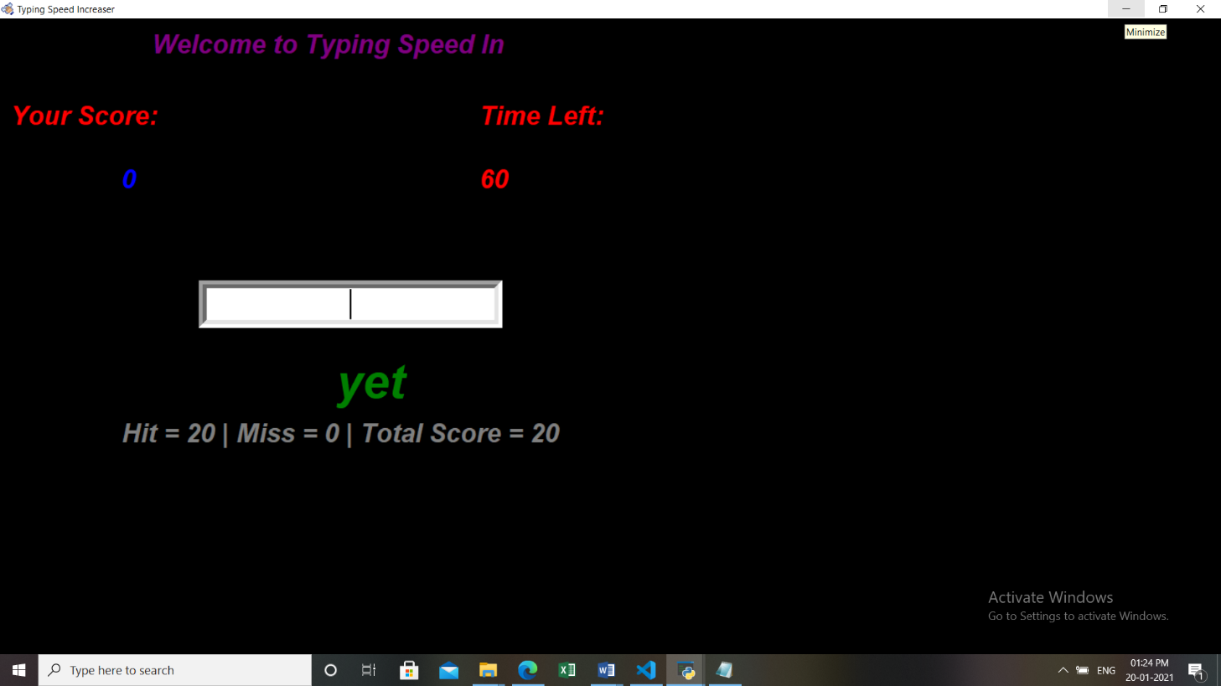

FIG 3: Typing Speed Increaser

**CHAPTER-7**

**CONCLUSION AND FUTURE SCOPE REFERENCES**

By the project we concluded that this project can be very much useful for the beginners nwho want to make their typing speed fast .They can use this app for their daily practice of typing through which they will gradually get better at the work . Finally, because touch-typing is such a useful skill that boosts productivity in the workplace, it can help you to find more and better opportunities when it comes to getting a job.

When applying for a job, being able to type fast and accurately is going to put you at a big advantage. Employers like to know that their employees can type properly because it will make them more productive and improve the accuracy of their work.